**API Integration Report- Aromas**

**Asaad Hussain**

**00414030**

**GIAIC, Quarter 2**

**18th January 2025**

**Table of Content**

|  |  |  |
| --- | --- | --- |
| API integration process |  | 3 |
| Adjustment to Schema |  | 3 |
| Migration Steps and tools |  | 4 |
| Screenshots |  | 4 |
|  |  |  |

**API integration process**

**Creating own API**

As no proper API was available online, I created my own API for perfumes,

A data file is created where all the data is put, then this GET and returned as a json, the API is hosted on vercel

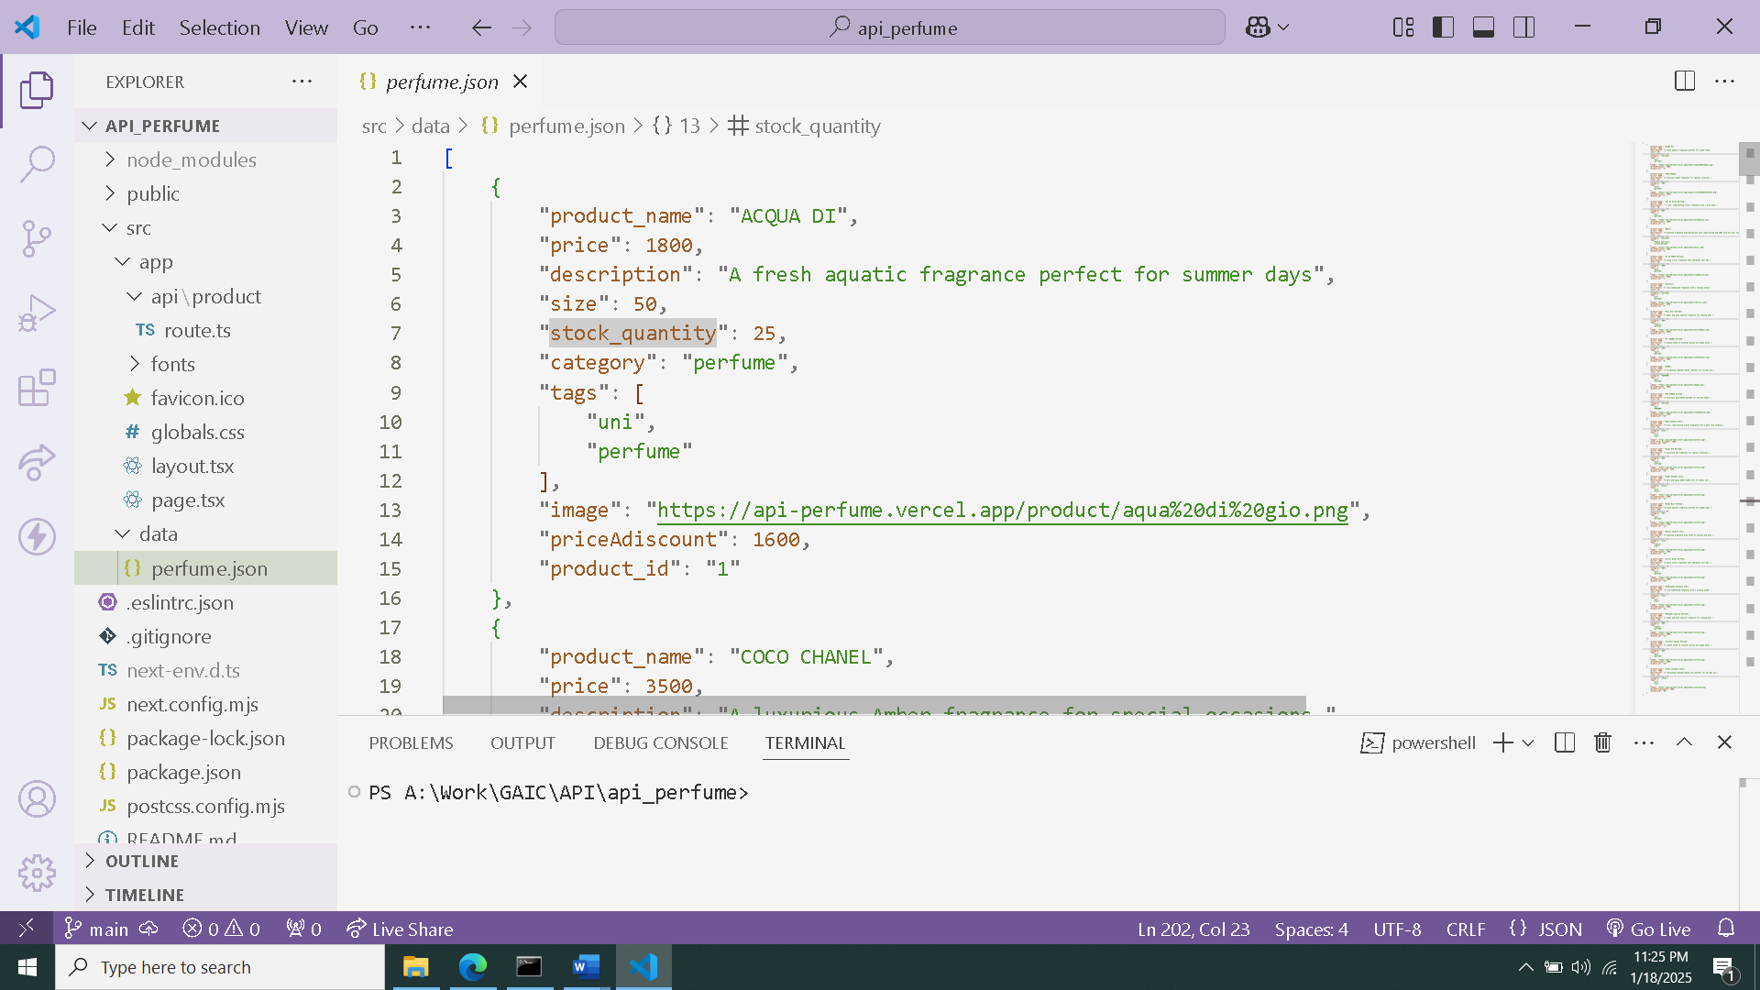

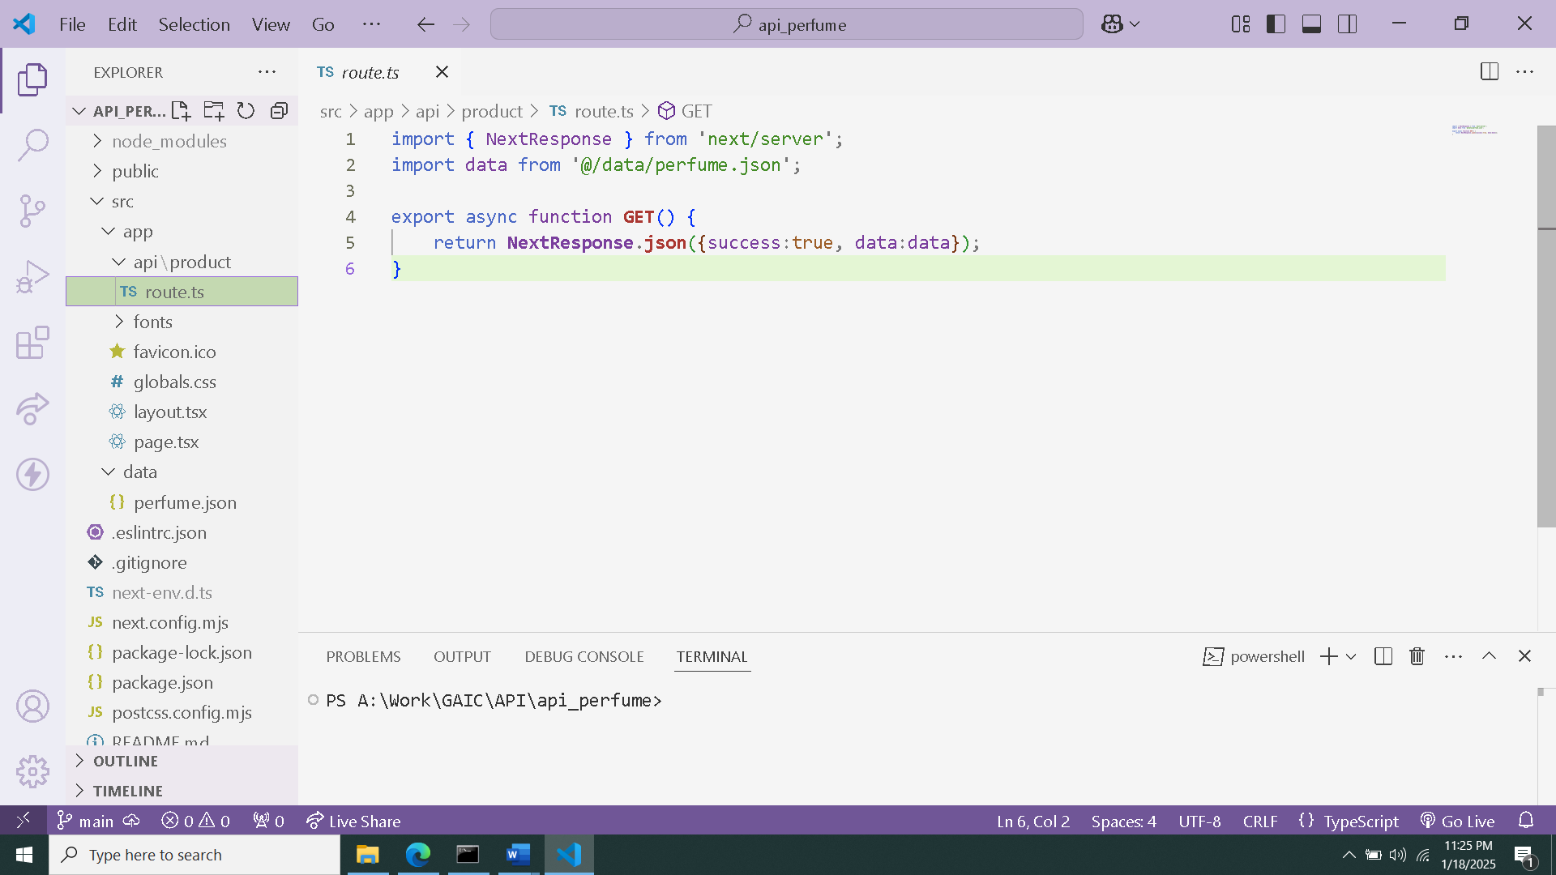

**Integration of API**  
A file is made in the src directory of the next app with the name of getProducts.ts in that 2 functions are written, both getting products from the sanity studio a GROQ query is written in the fetch function which is a function of client

In the main page,tsx of the app directory where some products are returned an interface is created to handle type of the data fetched the function is called and the data returned is mapped to show card component

**Adjustments made to schemas**

The adjustment made to schema was according to data api, the scema created in sanity and the names of the data in the migration should be same.

**Migration steps and tools used**

* For migration of the api data to sanity, a scripts folder is created in that a file importData.mjs,
* Secondly in the .env file the project id of the sanity and the data set type with the API token is stored.
* A client is needed to set with the above set credentials
* There are 2 functions one uploads the Images and the other imports the data, It is important to correctly set the schema

**Tools used**

* **Axios** a popular, promise-based HTTP client for JavaScript that simplifies making HTTP requests to REST endpoints.
* **.env** a file where all secret keys and API’s are stored and it is put in .gitignore
* **sanity** Cloud-based, open source unified content platform
* **API** **token** , token created from sanity

**Screenshots**

**API calls**

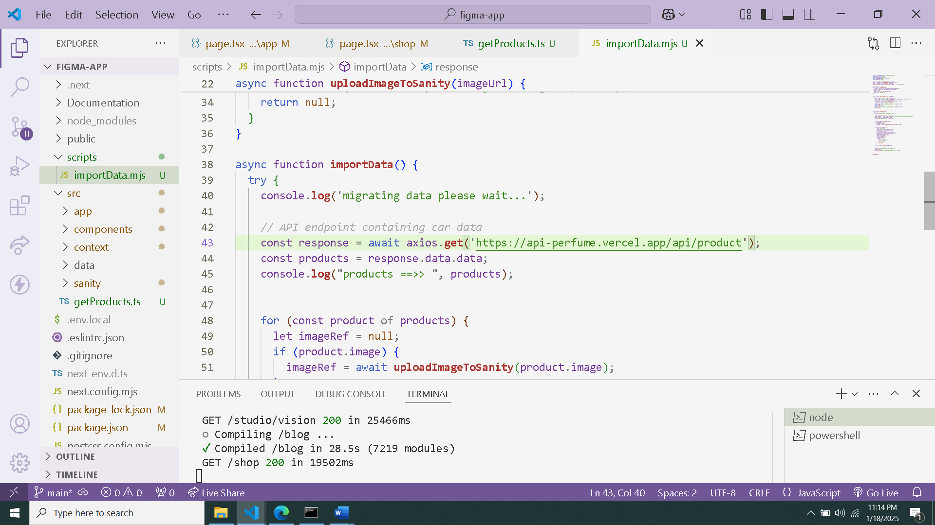

**Data successfully displayed in the frontend**

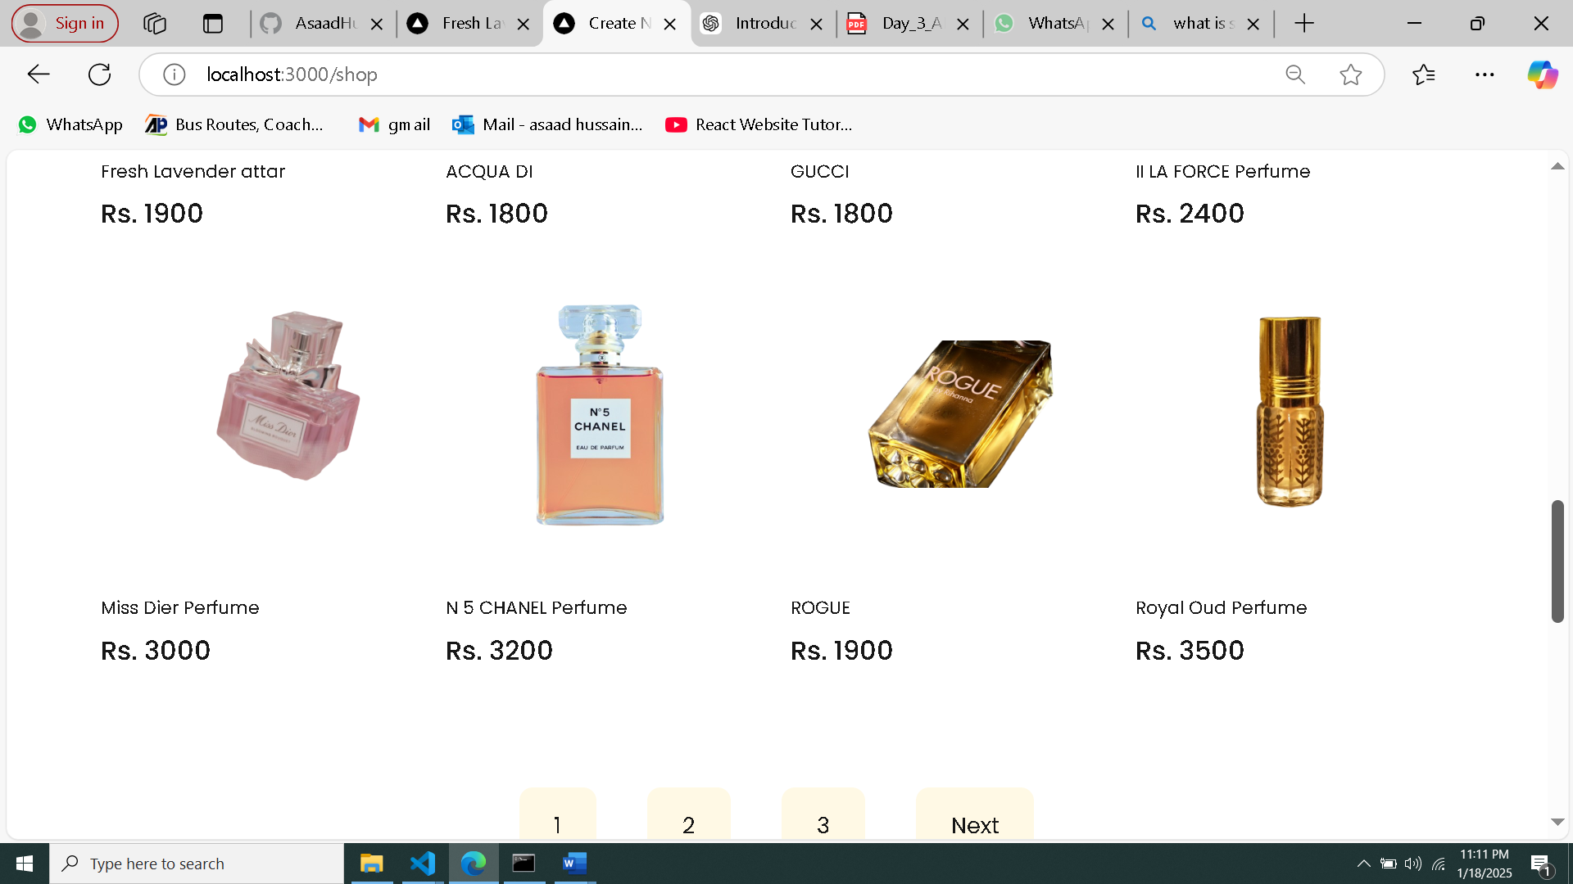

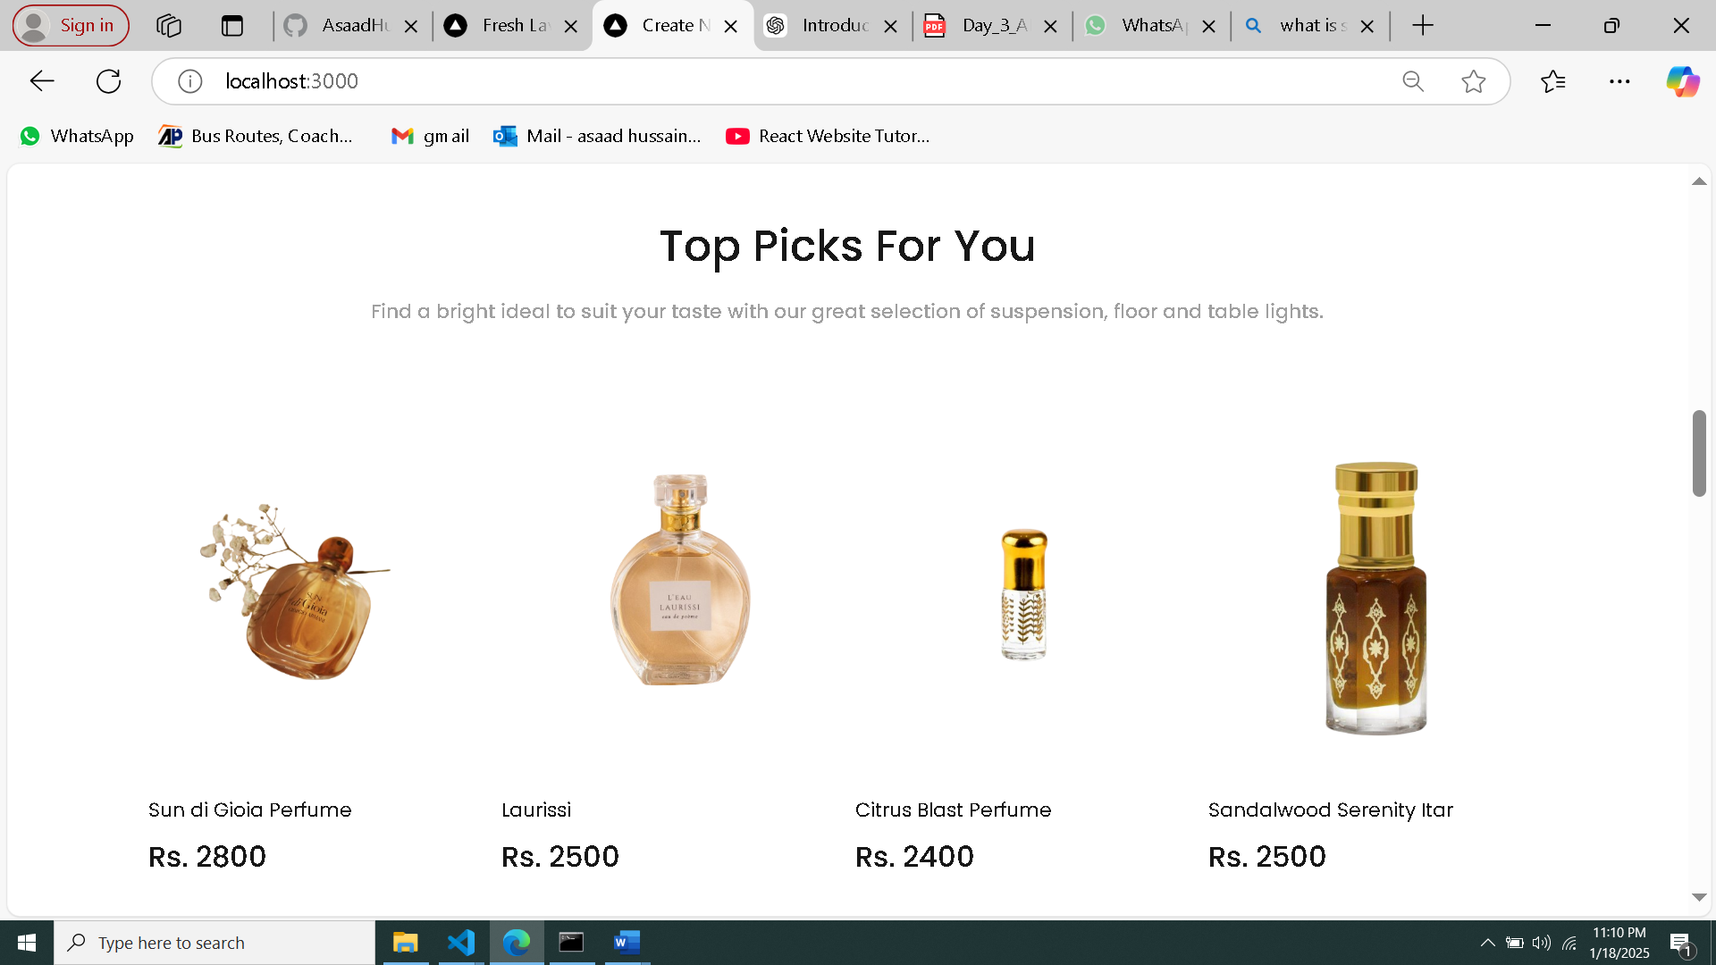

**Populated sanity CMS fields**

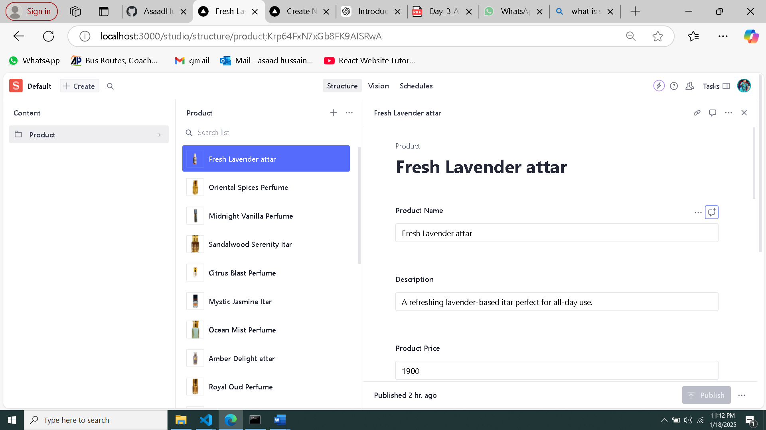

**Code snippets for API integration and migration scripts**

